承 认 书

SPECIFICATION FOR APPROVAL
`
客 户
CUSTOMER
客户品名 (材质)  CUSTOMER P/N （Material） | ATQ18/15.7/13 (PC96)
客户料号
CUSTOMER P/N
康明品名 (材质)  WAN LI P/N （Material） | ATQ18/15.7/13 (KM96)
认可书编号
SPEC.NO.

客户确认APPROVED BY：
(为保证订单顺利,请在1个月内确认回复)
(TO ensure smooth order, Please within one month to confirm reply)

批 准  APPROVED BY | 审 核  CHECKED BY | 拟 制  PREPARED BY | 日 期  DATE
 |  |  | 12-26

变 更 记 录
Change Take Notes
序号  No: | 变更内容及原因  Change contents and reason | 日期  Change Date | 担当  Drawn

Material | P/N | Customer P/N
KM96 | ATQ18/15.7/13 | ATQ18B
1. KM96材质特性 KM95 Material characteristics

初始磁导率μi  Initial permeability | 25℃ | 3100±25%
相对损耗因数tanδ/µi  Relative loss factor | 25℃ | ＜3×10⁻⁶
饱和磁通密度Bs（mT）  Saturation flux density 1194A/m | 25℃ | 520
饱和磁通密度Bs（mT）  Saturation flux density 1194A/m | 100℃ | 420
剩磁Br（mT）  Residual flux density | 25℃ | 85
矫顽力 Hc（A/m）  Coercive force | 25℃ | 12
功率损耗Pcv（kw/m³）  Power loss  25kHz, 200mT | 25℃ | Pcv（kw/m³）
功率损耗Pcv（kw/m³）  Power loss  25kHz, 200mT | 60℃ | Pcv（kw/m³）
功率损耗Pcv（kw/m³）  Power loss  25kHz, 200mT | 100℃ | Pcv（kw/m³）
功率损耗Pcv（kw/m³）  Power loss  25kHz, 200mT | 120℃ | Pcv（kw/m³）
功率损耗Pcv（kw/m³）  Power loss  100kHz, 200mT | 25℃ | Pcv（kw/m³） | 450
功率损耗Pcv（kw/m³）  Power loss  100kHz, 200mT | 60℃ | Pcv（kw/m³） | 470
功率损耗Pcv（kw/m³）  Power loss  100kHz, 200mT | 100℃ | Pcv（kw/m³） | 450
功率损耗Pcv（kw/m³）  Power loss  100kHz, 200mT | 120℃ | Pcv（kw/m³） | 480
居里温度Tc （℃）  Curie temperature | ＞230
电阻率ρ （）  Resistance | 6.5
密度d （g/cm³）  Density | 4.8
注：如无特殊说明，各项数值均系采用H38×19×6环形磁芯在室温下测得。
Note： The Values were obtained with toroidal cores at room temperature unless otherwise shown.

Material | P/N | Customer P/N
KM96 | ATQ18/15.7/13 | ATQ18B
2.KM96材质特性曲线 KM96 Material characteristics curve

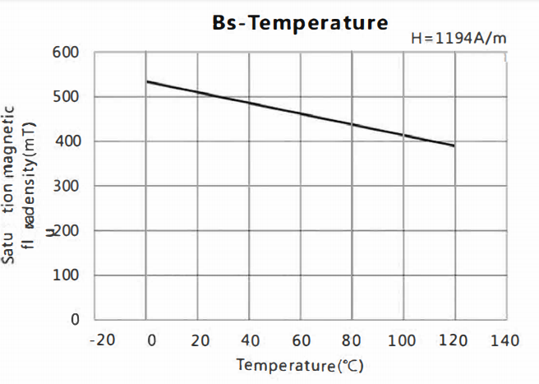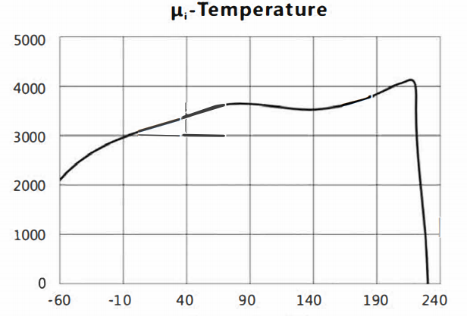

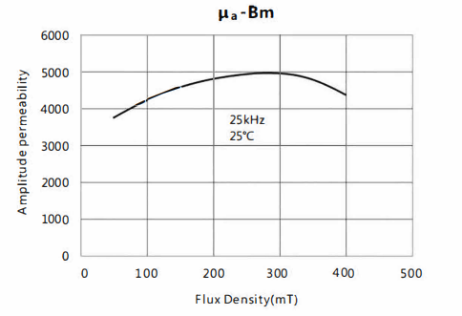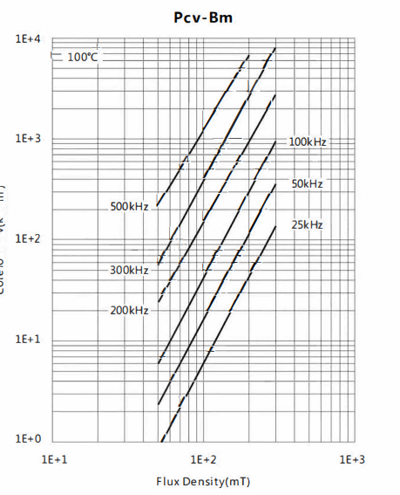

Material | P/N | Customer P/N
KM96 | ATQ18/15.7/13 | ATQ18B
- 产品外形和尺寸 Shape and dimensions

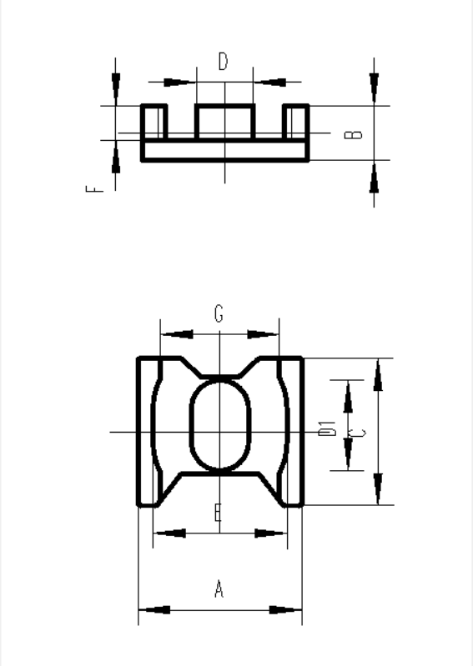 |  |  | 尺 寸  DIMENSIONS(mm)
 |  |  | A |  | 17.5±0.3
 |  |  | B |  | 6.3±0.2
 |  |  | C |  | 15.7±0.3
 |  |  | D |  | 6.0±0.3
 |  |  | D1 |  | 9.6±0.3
 |  |  | E |  | 14.2±0.3
 |  |  | F |  | 4.1±0.2
 |  |  | G |  | 12.6±0.3
磁芯配对误差;|A-A'|≤0.2mm （中柱边上带一点）
磁芯参数 CORE PARAMETERS
Le ( mm) | Ae ( mm⁻²) | Ve ( mm³) |  | 重量Weight
21.14 | 66.21 | 2128.3 |  | 12.1

Material | P/N | Customer P/N
KM96 | ATQ18/15.7/13 | ATQ18B

4.电磁和机械性能 Electromagnetic and mechanical property

(1) 电感因数 AL =2000±25% nH/N²
Inductance factor

• 测试温度 T = 25±3℃
Test Temperature
• 测试频率和电压 f = 1 kHz ； V= 0.3 v
Test Frequency And Voltage
• 测试线圈 N = 100 Ts
Test Coil
• 气隙量
Gap Lengths
• 测试仪器 YD2810 or eq.
Test Equipment

测量时在磁芯上压力F = 9.8 N
Exert 9.8 Newtonian forces on the cores when testing inductance

（2）功率损耗
Power Loss PcV 1 ≤500 Kw/cm³
PcV2 ≤500 Kw/cm³

• 测试温度 T 1= 25±3℃
T2=100±3℃
Test Temperature
• 测试频率 f = 100 kHz
Test Frequency
• 磁通密度 B_{m}= 200 mT
Peak Flux Density
• 测试仪器 CH2335 or eq.
Test Equipment

测量时在磁芯上压力F = 9.8 N
Exert 9.8 Newtonian forces on the cores when testing powerloss

Material | P/N | Customer P/N
KM96 | ATQ18/15.7/13 | ATQ18B
(3) 饱和磁通密度
Saturation Flux Density Bs≥ 400 mT

• 测试温度 T = 100±3℃
Test temperature
• 测试条件 H = 1194 A/m ；f = 1kHz
Test Condition
测量时在磁芯上施加力F = 9.8N
Exert 9.8 Newtonian forces on the cores when testing Bs

(4 ) 机械强度 (图1) F₁≥ 6 N

Mechanical Strength（Fig.1）

• 测试方法 FSJ2000(The pull speed:20mm/min)
Test Method:

F₁ F₁

4mm

Fig.1

Material | P/N | Customer P/N
KM96 | ATQ18/15.7/13 | ATQ18B
5. 外观标准Appearance requirement

（1）磁芯表面清洁、无明显的疏松现象，磨加工面平整。每板磁芯色泽均匀。
The surface of the core should be clean, smooth and no loose area, the color must be showing non apparent difference each board and the ground surface must be flat.
（2）磁芯配合面上裂缝深度不超过0.2mm，长度不超过延长线长度的1/4,磁芯非配合面上裂缝深度不超过0.4mm，长度不超过延长线长度的1/3
The depth of crack in the ground surface should be no more than 0.2mm, length is no more than 1/4 length of lengthen line. In the non-ground surface, the depth should be no more than 0.4mm length is no more than 1/3 length of lengthen line.
（3）磁芯表面掉块（破损） Surface chips （damaged）
 |  | 接合面  Joint surface | 其它表面  Other surface
破损  Damaged | 处破损的面积 A damaged area | ≤0.5mm² | ≤0.8mm²
破损  Damaged | 处以上破损面积合计 Two or more total damaged area | ≤1.0mm² | ≤3.0mm²
破损  Damaged | 破损深度 Damaged depth | ≤0.5mm | ≤0.8mm
（4）磁芯表面结晶 Surface bright crystal
结晶直径  largest diameter of bright crystal（mm） |  | 结晶数量 number  个/只磁芯（A/per core） |  | 结晶计数起始直径（mm）  the counting initiation diameter
暴露面 exposed surface | 非暴露面  (包括配合面)  non-exposed surface  （including with the surface） | 暴露面exposed surface | 非暴露面  (包括配合面)  non-exposed surface（including with the surface）
Φ≤1.5 | Φ≤2 | ≤2 | ≤3 | 0.5

（5）粘模：面积≤粘模所在面面积的1/4 pull-out: area≤location surface area 1/4
（6）毛刺:磁芯边缘允许有不影响使用的不易脱落的毛刺存在。不影响使用毛刺高度不超过所在平面位置。
Burr: There are burrs on the edge if the burrs don't affect usage and isn’t easy to come off. The burr can not exceed the height of the local surface height
（7）其它影响产品性能的缺陷不允许存在。
All other defects that can affect the ferrite performances, don’t allow too.

Material | P/N | Customer P/N
KM96 | ATQ18/15.7/13 | ATQ18B
6. 检验方法 Inspection method
按ＧＢ/T2828.1-2003，一次正常抽样，检查水平Ⅱ，ＡＱＬ符合下列标准。
According to GB/T2828.1-2003.one time normal random sampling, Inspect level Ⅱ, AQL should be as follows;
 | 合格质量水平AQL | 检查项目Inspect Item
A | 0.65 | 电磁特性Electromagnetic property
B | 1.0 | 外形尺寸Shape size
C | 1.5 | 外观质量Appearance quality

